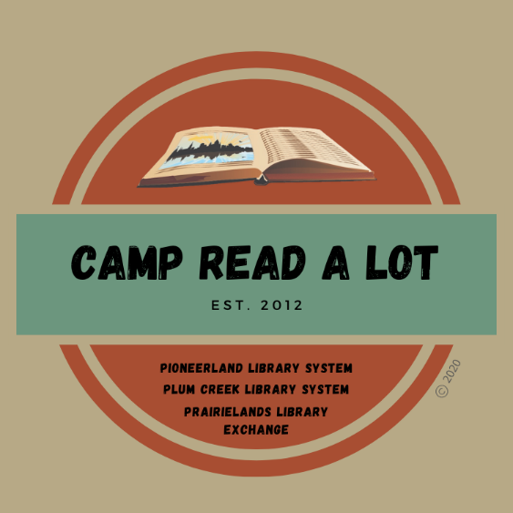
EARLY LITERACY
BOOK REPORTS

Please read the 20 titles listed plus two “Camper’s Choice” selections prior to Camp. Reports should be submitted no later than August 1, 2022, and should include your personal reaction to the book and how you might use the book in your library or classroom. In order to earn 25 continuing education credits per day, you must read the entire list, report on each book and attend Camp Read-a-Lot on August 2, 2022, either in person or online.

Note: reports will be made on this sheet: click on the blue text and enter your report (the box will expand
as you type) or you can space between titles, print the sheet, and write in your reports by hand. If you share your file through Google Documents, PLEASE be sure to allow access without permission required.

- A New Day, by Brad Meltzer
Click here to provide your personal reaction to this title including how you would use the book in your library or classroom.

- Bright Star, by Yuyi Morales
Click here to provide your personal reaction to this title including how you would use the book in your library or classroom.

- Cat Problems, by Jory John
Click here to provide your personal reaction to this title including how you would use the book in your library or classroom.

- Change Sings: a children's anthem, by Amanda Gorman
Click here to provide your personal reaction to this title including how you would use the book in your library or classroom.

- Chez Bob, by Bob Shea
Click here to provide your personal reaction to this title including how you would use the book in your library or classroom.

- Eyes That Kiss in the Corners, by Joanna Ho and Dung Ho
Click here to provide your personal reaction to this title including how you would use the book in your library or classroom.

- Fish and Sun, by Sergio Ruzzier
Click here to provide your personal reaction to this title including how you would use the book in your library or classroom.

- Fred Gets Dressed, by Peter Brown
Click here to provide your personal reaction to this title including how you would use the book in your library or classroom.

- Inside Cat, by Brendan Wenzel
Click here to provide your personal reaction to this title including how you would use the book in your library or classroom.

- Mel Fell, by Corey R. Tabor
Click here to provide your personal reaction to this title including how you would use the book in your library or classroom.

- Milo Imagines the World, by Matt de la Peña
Click here to provide your personal reaction to this title including how you would use the book in your library or classroom.

- Norman Didn't Do It!: (Yes, He Did), by Ryan T. Higgins
Click here to provide your personal reaction to this title including how you would use the book in your library or classroom.

- Princess in Black and the Giant Problem, by Shannon Hale & Dean Hale
Click here to provide your personal reaction to this title including how you would use the book in your library or classroom.

- Rock From the Sky, by Jon Klassen
Click here to provide your personal reaction to this title including how you would use the book in your library or classroom.

- Someone Builds the Dream, by Lisa Wheeler
Click here to provide your personal reaction to this title including how you would use the book in your library or classroom.

- Time for Kenny, by Brian Pickney
Click here to provide your personal reaction to this title including how you would use the book in your library or classroom.

- Watercress, by Andrea Wang
Click here to provide your personal reaction to this title including how you would use the book in your library or classroom.

- Zonia's Rain Forest, by Juana Martinez-Neal
Click here to provide your personal reaction to this title including how you would use the book in your library or classroom.

- It fell from the sky, by the Fan Brothers
Click here to provide your personal reaction to this title including how you would use the book in your library or classroom.

- Bodies are cool, by Tyler Feder
Click here to provide your personal reaction to this title including how you would use the book in your library or classroom.

CAMPER’S CHOICE: (Select any title by our keynote author to read and review)
Click here to provide your personal reaction to this title including how you would use the book in your library or classroom.
TITLE:
AUTHOR:

CAMPER’S CHOICE: Select a title of your choice (fiction or non-fiction) that meets the following criteria:
- You have not read it before this summer
- Original copyright is no older than 2017
- Ideal for classroom use or free reading
Click here to provide your personal reaction to this title including how you would use the book in your library or classroom.
TITLE:
AUTHOR:

SEND REPORTS TO:
Rebecca Hudson
rhudson@plumcreeklibrary.net
or:
Plum Creek Library System
PO Box 697
Worthington, MN 56187

