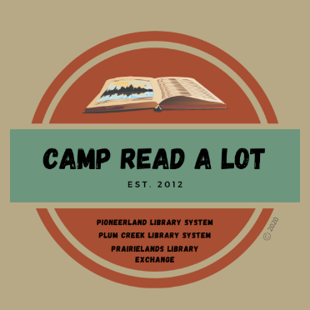
GRADES 5-8
BOOK REPORTS
Please read the 12 titles listed plus two “Camper’s Choice” selections prior to Camp. Reports should be submitted no later than August 1, 2022, and should include your personal reaction to the book and how you might use the book in your library or classroom. In order to earn 25 continuing education credits per day, you must read the entire list, report on each book and attend Camp Read-a-Lot on August 2, 2022, either in person or online.

Note: reports will be made on this sheet: click on the blue text and enter your report (the box will expand
as you type) or you can space between titles, print the sheet, and write in your reports by hand. If you share your file through Google Documents, PLEASE be sure to allow access without permission required.

- Desolations of Devil’s Acre, by Ransom Riggs
Click here to provide your personal reaction to this title including how you would use the book in your library or classroom.

- Ground Zero, by Alan Gratz
Click here to provide your personal reaction to this title including how you would use the book in your library or classroom.

- Instructions for Dancing, by Nicola Yoon
Click here to provide your personal reaction to this title including how you would use the book in your library or classroom.

- Kaleidoscope, by Brian Selznick
Click here to provide your personal reaction to this title including how you would use the book in your library or classroom.

- Last Cuentista, by Donna Barba Higuera
Click here to provide your personal reaction to this title including how you would use the book in your library or classroom.

- Pony, by R. J. Palacio
Click here to provide your personal reaction to this title includinghow you would use the book in your library or classroom.

- Starfish, by Lisa Fipps
Click here to provide your personal reaction to this title including how you would use the book in your library or classroom.

- You Have a Match, by Emma Lord
Click here to provide your personal reaction to this title including how you would use the book in your library or classroom.

- Fallout: Spies, Superbombs, and the Ultimate Cold War Showdown, by Steve Sheinkin Click here to provide your personal reaction to this title including how you would use the book in your library or classroom.

- Gone to the Woods: Surviving a Lost Childhood, by Gary Paulsen
Click here to provide your personal reaction to this title including how you would use the book in your library or classroom.

- Puberty Is Gross but Also Really Awesome, by Gina Loveless
Click here to provide your personal reaction to this title including how you would use the book in your library or classroom.

- Sea-Ringed World: Sacred Stories of the Americas, by María García Esperón
Click here to provide your personal reaction to this title including how you would use the book in your library or classroom.

CAMPER’S CHOICE: (Select any title by our keynote author to read and review)
Click here to provide your personal reaction to this title including how you would use the book in your library or classroom.

TITLE:
AUTHOR:

CAMPER’S CHOICE: Select a title of your choice (fiction or non-fiction) that meets the following criteria:
- You have not read it before this summer
- Original copyright is no older than 2017
- Ideal for classroom use or free reading
Click here to provide your personal reaction to this title including how you would use the book in your library or classroom.

TITLE:
AUTHOR:

SEND REPORTS TO:
Rebecca Hudson
rhudson@plumcreeklibrary.net
or:
Plum Creek Library System
PO Box 697
Worthington, MN 56187

