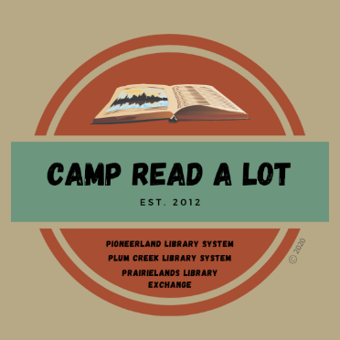
GRADES 2-4
BOOK REPORTS
Please read the 12 titles listed plus two “Camper’s Choice” selections prior to Camp. Reports should be submitted no later than August 1, 2022, and should include your personal reaction to the book and how you might use the book in your library or classroom. In order to earn 25 continuing education credits per day, you must read the entire list, report on each book and attend Camp Read-a-Lot on August 2, 2022, either in person or online.

Note: reports will be made on this sheet: click on the blue text and enter your report (the box will expand
as you type) or you can space between titles, print the sheet, and write in your reports by hand. If you share your file through Google Documents, PLEASE be sure to allow access without permission required.

Fiction
- Amari and the Night Brothers, by B. B. Alston
Click here to provide your personal reaction to this title including how you would use the book in your library or classroom.

- Beatryce Prophecy, by Kate DiCamillo
Click here to provide your personal reaction to this title including how you would use the book in your library or classroom.

- Billy Miller Makes a Wish, by Kevin Henkes
Click here to provide your personal reaction to this title including how you would use the book in your library or classroom.

- Frankie & Bug, by Gayle Forman
Click here to provide your personal reaction to this title including how you would use the book in your library or classroom.

- How to Train Your Dad, by Gary Paulsen
Click here to provide your personal reaction to this title including how you would use the book in your library or classroom.

- Katie the Catsitter, by Colleen AF Venable
Click here to provide your personal reaction to this title including how you would use the book in your library or classroom.

- Maybe Maybe Marisol Rainey, by Erin Entrada Kelly
Click here to provide your personal reaction to this title including how you would use the book in your library or classroom.

- The Last Kids on Earth and the Doomsday Race, by Max Brallier & Douglas Holgate
Click here to provide your personal reaction to this title including how you would use the book in your library or classroom.

- The Lion of Mars, by Jennifer L. Holm
Click here to provide your personal reaction to this title including how you would use the book in your library or classroom.

- Born on the Water, Nikole Hannah-Jones et. al.
Click here to provide your personal reaction to this title including how you would use the book in your library or classroom.

- Race to the Bottom of the Earth, by Rebecca Barone
Click here to provide your personal reaction to this title including how you would use the book in your library or classroom.

- Unspeakable: The Tulsa Race Massacre, by Carole Boston Weatherford
Click here to provide your personal reaction to this title including how you would use the book in your library or classroom.

CAMPER’S CHOICE: (Select any title by our keynote author to read and review)
Click here to provide your personal reaction to this title including how you would use the book in your library or classroom.
TITLE:
AUTHOR:

CAMPER’S CHOICE: Select a title of your choice (fiction or non-fiction) that meets the following criteria:
- You have not read it before this summer
- Original copyright is no older than 2017
- Ideal for classroom use or free reading
Click here to provide your personal reaction to this title including how you would use the book in your library or classroom.
TITLE:
AUTHOR:

SEND REPORTS TO:
Rebecca Hudson
rhudson@plumcreeklibrary.net
or:
Plum Creek Library System
PO Box 697
Worthington, MN 56187

