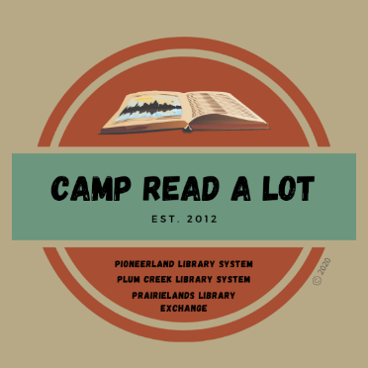
GRADES 9-12
BOOK REPORTS
Please read the 11 titles listed plus two “Camper’s Choice” selections prior to Camp. Reports should be submitted no later than August 1, 2022, and should include your personal reaction to the book and how you might use the book in your library or classroom. In order to earn 25 continuing education credits per day, you must read the entire list, report on each book and attend Camp Read-a-Lot on August 2, 2022, either in person or online.

Note: reports will be made on this sheet: click on the blue text and enter your report (the box will expand
as you type) or you can space between titles, print the sheet and write in your reports by hand.

- Mister Impossible (Dreamer Trilogy #2), by Maggie Stiefvater
Click here to provide your personal reaction to this title including how you would use the book in your library or classroom.

- Beasts of Prey, by Ayana Gray
Click here to provide your personal reaction to this title including how you would use the book in your library or classroom.

- Gilded, by Marissa Meyer
Click here to provide your personal reaction to this title including how you would use the book in your library or classroom.

- You'll be the Death of Me, by Karen M. McManus
Click here to provide your personal reaction to this title including how you would use the book in your library or classroom.

- Firekeeper’s Daughter, by Angeline Boulley
Click here to provide your personal reaction to this title including how you would use the book in your library or classroom.

- Concrete Rose, by Angie Thomas
Click here to provide your personal reaction to this title including how you would use the book in your library or classroom.

- The Betrothed, by Kiera Cass
Click here to provide your personal reaction to this title including how you would use the book in your library or classroom.

- Six Crimson Cranes, by Elizabeth Lim
Click here to provide your personal reaction to this title including how you would use the book in your library or classroom.

- We Must Not Forget: Holocaust Stories of Survival and Resistance, by Deborah Hopkinson
Click here to provide your personal reaction to this title including how you would use the book in your library or classroom.

- In the Shadow of the Fallen Towers, by Don Brown
Click here to provide your personal reaction to this title including how you would use the book in your library or classroom.

- The Hill We Climb: An Inaugural Poem for the Country, by Amanda Gorman
Click here to provide your personal reaction to this title including how you would use the book in your library or classroom.

CAMPER’S CHOICE: (Select any title by our keynote author to read and review)
Click here to provide your personal reaction to this title including how you would use the book in your library or classroom.

TITLE:
AUTHOR:

CAMPER’S CHOICE: Select a title of your choice (fiction or non-fiction) that meets the following criteria:
- You have not read it before this summer
- Original copyright is no older than 2017
- Ideal for classroom use or free reading
Click here to provide your personal reaction to this title including how you would use the book in your library or classroom.

TITLE:
AUTHOR:

SEND REPORTS TO:
Rebecca Hudson
rhudson@plumcreeklibrary.net
or:
Plum Creek Library System
PO Box 697
Worthington, MN 56187

