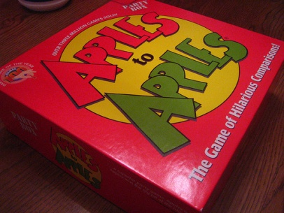
Modern Board Games Kit – Specific Things to Know

- Be sure to check that all the pieces are included. If not, please notify SAMMIE and we’ll try to replace them!

- If the instructions for a particular game were damaged or are missing you are able to download a new copy on our website (SAMMIE Home > Teen Resources > Teen Programming Kits).

Programming Ideas

- Board game tournaments.
- Have a passive program in which you just have the games out to be used during the entire check-out period and just let the teen use them when they’re able.
- Use it with:
  - the Classic-Board Games kit for bigger tournaments.
  - the Classic-Board Games kit and the Video Gaming kit for entertainment during a lock-in.
- Celebrate National Gaming Day (November)

