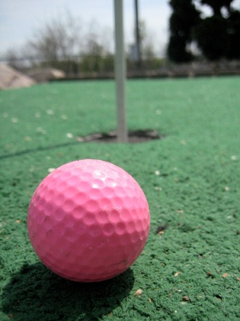
Mini-Golf Kit – Specific Things to Know

- Be sure to check the items to make sure none are broken. If something is, please notify SAMMIE immediately!

- Be sure that when you promote this kit you warn patrons that during the time/date of the program it might be louder in the library area in which it will be used. This way you’re being accommodating to those individuals who come to the library and expect it to be a quieter environment.

- Enforce the boundaries of where this event will be taking.

- Perforated balls are recommended for use indoors.

- Because accidents may occur we advise that you utilize a parental release/permission slip.

Programming Ideas

- Use during a time particular to golf either nationally (Masters) or locally (annual Charity event) or during National Golf Month (August), along with a display of golf titles.
- Do a multi-date event: 2 separate dates to build their own obstacles, and one further date to play using them.
- Collaboration:
  - Work with local math teachers and high school geometry classes design obstacles for the library, and then set up a date for them to come and play.
  - Work with locate art students to design obstacles for the library and then set up a date for them to come and play.
  - Have local businesses sponsor the creation of the obstacles.

