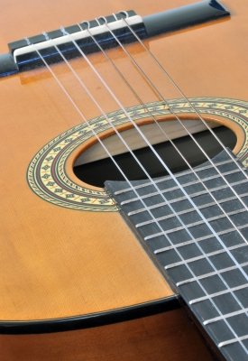
Instruments Kit – Specific Things to Know

- Be sure to check the items to make sure that they work. If not, please notify SAMMIE immediately!

- Be sure that when you promote this kit you warn patrons that during the time/date of the program it might be louder in the library area in which it will be used. This way you’re being accommodating to those individuals who come to the library and expect it to be a quieter environment.

- Make sure that you set the volume at an optimal level.

Programming Ideas

- Teen band performance.
- Use it with:
  - the Karaoke kit to record music.
  - the Lighting kit to do a “coffee shop” performance.
- Music mentorship program – have professionals come in and show teens how to play the instruments.
- As a passive program, set up an area in which teens came come in and try out the instruments.

