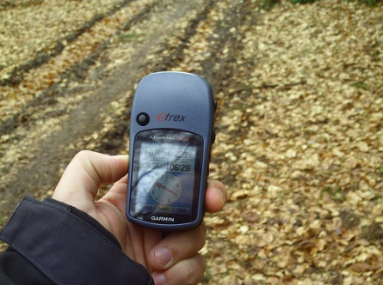
Geocaching – Specific Things to Know

- Be sure to check the equipment to make sure it works. If not, please notify SAMMIE immediately!

- Don’t store the batteries in the GPS units! It drains them more quickly. Please remember to remove them from the units before boxing up the kit.

- Because geocaching isn’t as well known we’ve included further materials regarding terminology, defining GPS and geocaching, kit specific programming prep work, a sample geocaching program, and other resources.

- Due to the nature of the program, it may require that the program take place outdoors at a location away from the library. Because of this we highly advise utilizing the Geocaching Program Permission Form, an example of which is provided in this binder, to make sure that the parents of the participants are fully advised of the program elements.

- Your local Park & Rec may have additional GPS units for you to use and/or may be able to aid you in both the learning how to use the unit and teach others as well.

Programming Ideas

- Make your own geocaches.
- If your library is large enough use a “cache” bookmark in a book as a GPS point.
- Go to a local park and use natural elements as GPS points.
- Use the GPS units for a scavenger hunt.

