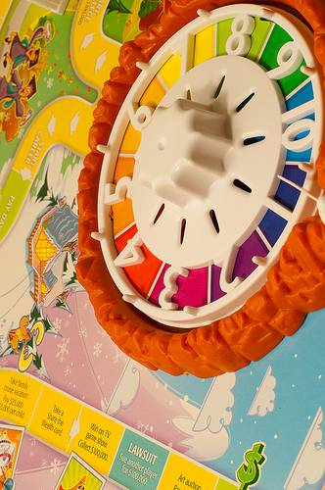

Classic

Board

Games

©SAMMIE 2012