STRING ART TAKE-AND-MAKE

WE PROVIDE:
book
nails
embroidery thread
two templates: Minnesota and maple leaf – but feel free to make whatever shape you’d like!

YOU PROVIDE:
hammer
pencil
INSTRUCTIONS

- Trace your template in pencil on the cover of your book.
- Pick a corner for your first nail. Do not nail it too deep, but it will need to be deep enough so it does not wiggle.
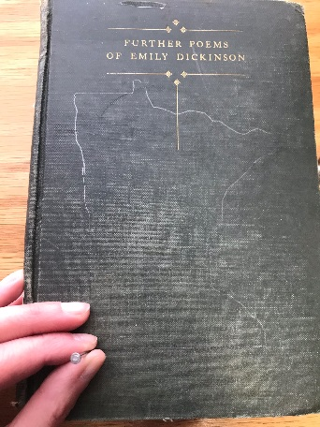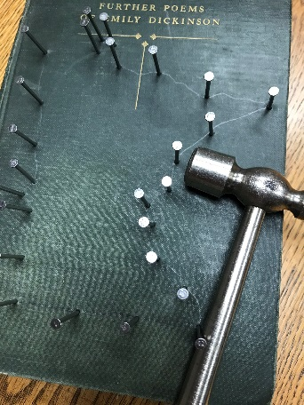
- Continue nailing around the outline, making sure not to put the nails too close together along the straighter edges.
- Gently tap any crooked nails on their sides so they all stand straight up and down. Check to make sure your nails are more or less the same height. Gently tap any down that are not.
- Taking your embroidery thread, choose a corner from which to start and tie your thread in a double knot around a nail.
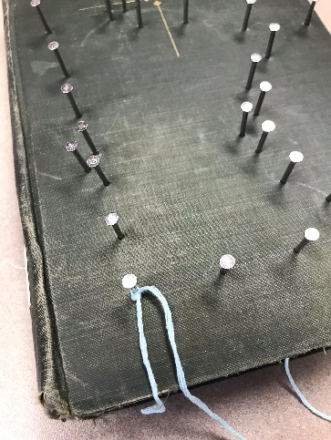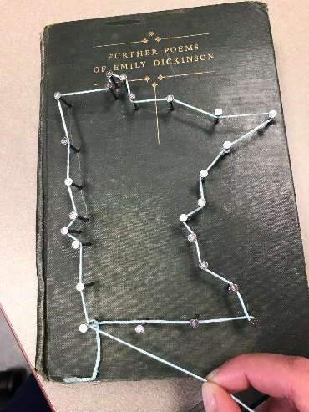
- Create a border around your outline by stringing the thread along the nails. This technique works best if you weave the string in and out – in front of one nail, behind the next, etcetera.
- Go around the outline one more time for definition. When your second outline is complete, push the thread down on the nails a bit to leave room for additional thread.
- Starting at one corner, take your thread, string it towards a different nail, and wrap it around the nail.
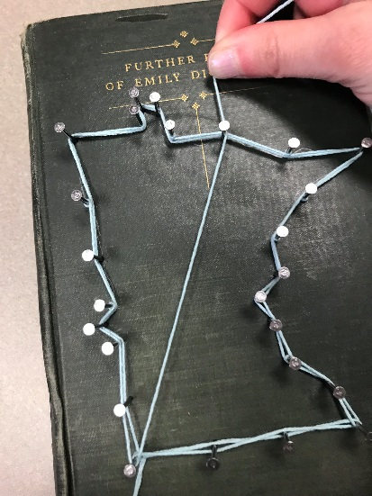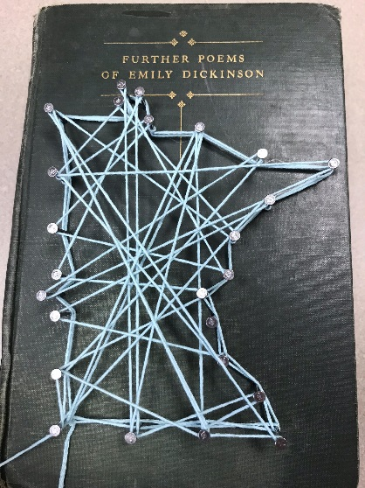
- Continuing to keep your thread tight, wrap the string around another nail. Wrap the thread back and forth around nails until you have wrapped each nail at least once, and you are happy with your string pattern.
- Tie your thread in a double knot around your ending nail. Trim off the extra thread ends from your first and last knots.
- Send a photo of your work to rocklibrarystaff@gmail.com to be entered to win a prize!

