DIY EGG CARTON GARDEN

THE LIBRARY PROVIDES:
egg carton
seeds

YOU WILL NEED:
soil
plastic wrap

- Cut off the top of the carton (save this for later).
- Lay the seeds in the carton.
- Cover the seeds with some soil, up to the bridges between the cells.

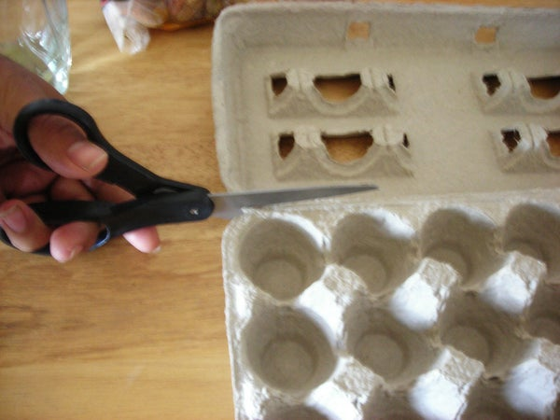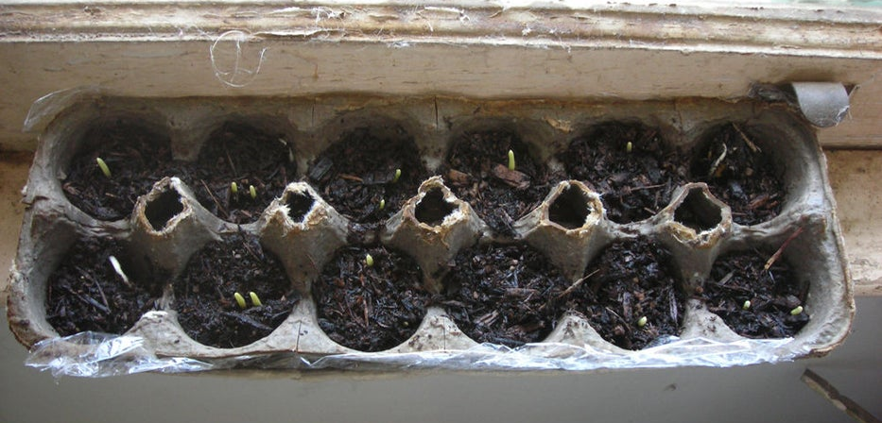

- Take the egg carton lid you cut off earlier. Place a layer of plastic wrap on top, big enough to have an inch hang off.
- Now place the cells into the lid (on top of the plastic wrap) and water the seeds. You will have a double layer, and the lid will act as a support to the cells (when they get wet, they will get weak).

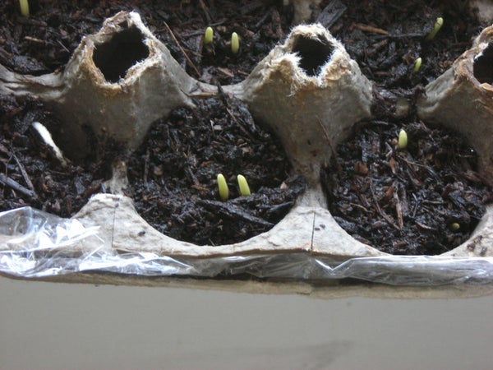

- When the plants are large enough (one week or so) transplant them into a larger container or directly into garden. The egg carton is biodegradable and the soil will help the plant with nutrients!

