PAPIER-MÂCHÉ BIRD
TAKE-AND-MAKE

WE PROVIDE: YOU PROVIDE:
cardboard ModPodge (watered down)
bird template markers
paper clips scissors
book pages tape (Scotch and duct)

INSTRUCTIONS

- Cut out the template and trace it onto your piece of cardboard.
- Cut out your bird. Bend the cardboard at the two dotted lines and fold the bird up so the two sides meet at the head.
- Place a piece of Scotch tape at the top of the head so the two sides are held together.
- Unbend the paper clips so they are straight. Bend one end into a loop to make the foot, and then bend that at a right angle so the bird will be able to stand.
- Poke the paper clips into the corrugated cardboard on each side of the bird, right in front of the center divide.
- Adjust to the height you want (the bird will be top-heavy, so shorter legs might work better), and then wrap a strip of duct tape around the very top of each leg to brace them and keep them in place.
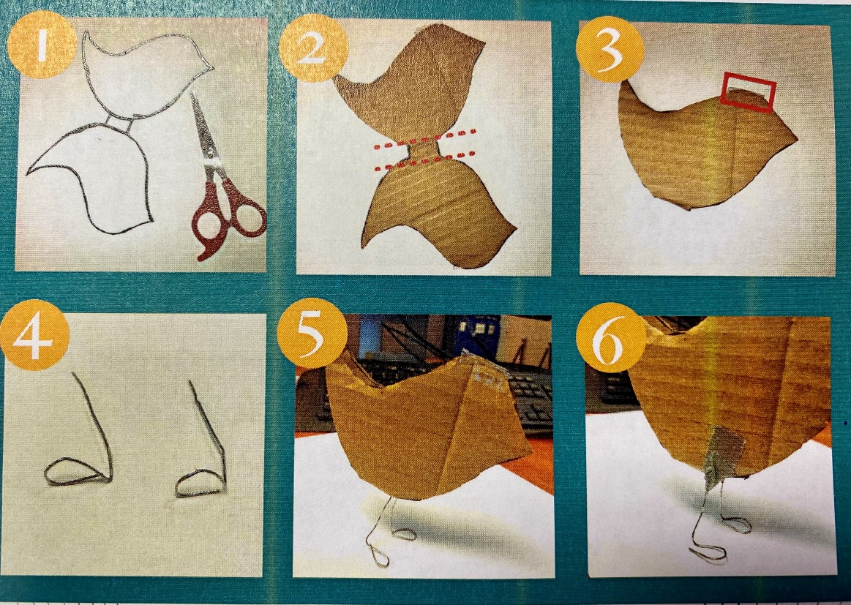
- Cut the book pages into strips.
- Brush the ModPodge liberally onto a strip and wrap it around the cardboard. Do this until the whole bird is covered.
- Once the bird is covered, let it dry for about ten minutes. Then put another coat of ModPodge over the entire bird to seal it.
- Let the bird completely dry before decorating it with markers.
- When you are finished, stand the bird up, bending the paperclip legs as necessary.
- Send a photo of your work to rocklibrarystaff@gmail.com to be entered to win a prize!

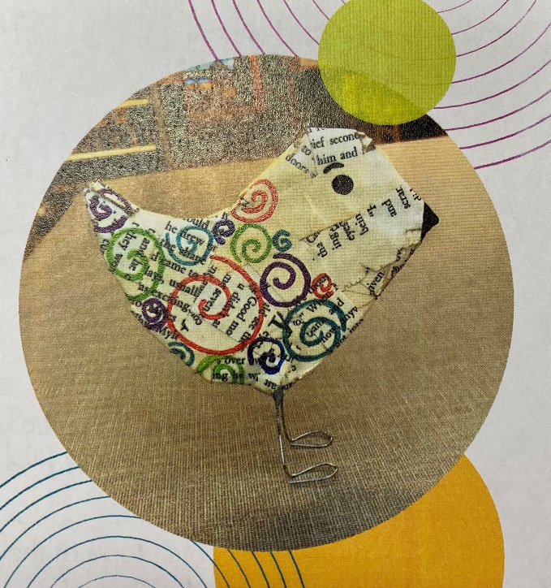

Thank you to the Brookings Public Library for sharing these instructions with us!

