FOLDED BOOK HEART
TAKE-AND-MAKE

WE PROVIDE: YOU PROVIDE:
book pencil
ruler (with centimeters)
INSTRUCTIONS
For this heart pattern, we need to mark and fold 40 book pages. Choose 40 pages that are approximately in the center of your book so it will stand up well on its own for display.
The pattern is in centimeters, so please use a ruler that has centimeter markings.
Pick up the book like normal (as if you are reading it). Now turn the book a quarter, so your hand ends up on the right of the book. Keep the book in this position as you mark it for the folds.
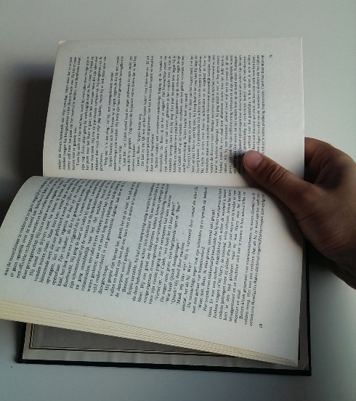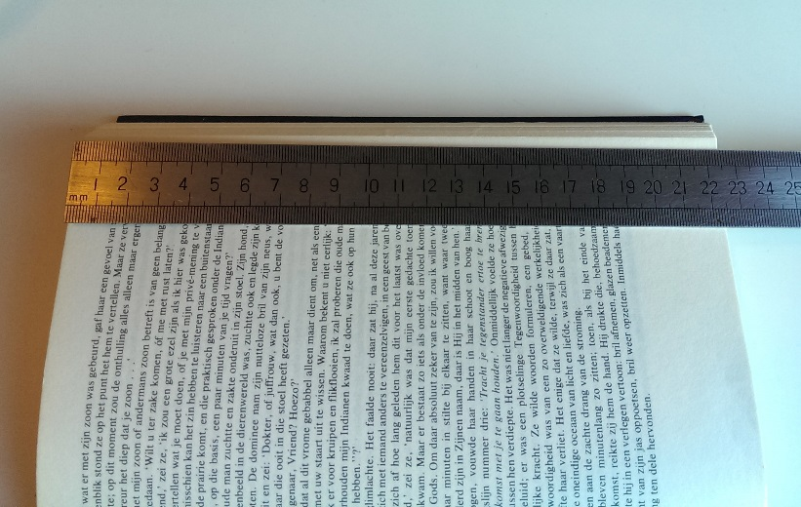
Place your ruler on the book. Make sure the beginning of the ruler is on the left side of the book.
The first two values you need to mark are: 7.7 centimeters and 8.9 centimeters. Place two marks on those two values.
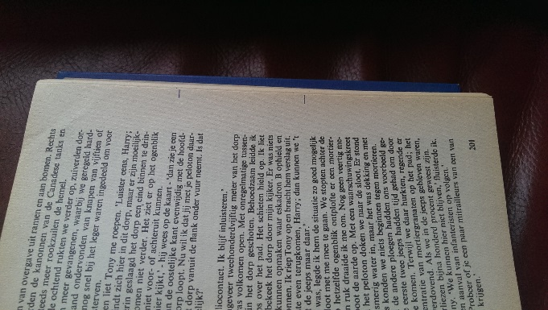
Now mark the rest of the pages!
Page 2: 7.1 & 9.6 Page 21: 7.1 & 14.6
Page 3: 6.8 & 10.1 Page 22: 6.8 & 14.4
Page 4: 6.6 & 10.5 Page 23: 6.6 & 14.2
Page 5: 6.4 & 10.9 Page 24: 6.4 & 14.0
Page 6: 6.3 & 11.2 Page 25: 6.2 & 13.7
Page 7: 6.2 & 11.6 Page 26: 6.1 & 13.5
Page 8: 6.1 & 11.8 Page 27: 6.1 & 13.3
Page 9: 6.0 & 12.1 Page 28: 6.0 & 13.1
Page 10: 6.0 & 12.4 Page 29: 6.0 & 12.8
Page 11: 6.0 & 12.6 Page 30: 6.0 & 12.6
Page 12: 6.0 & 12.8 Page 31: 6.0 & 12.4
Page 13: 6.0 & 13.1 Page 32: 6.0 & 12.1
Page 14: 6.1 & 13.3 Page 33: 6.1 & 11.8
Page 15: 6.1 & 13.5 Page 34: 6.2 & 11.6
Page 16: 6.3 & 13.7 Page 35: 6.3 & 11.2
Page 17: 6.4 & 14.0 Page 36: 6.4 & 10.9
Page 18: 6.6 & 14.2 Page 37: 6.6 & 10.5
Page 19: 6.8 & 14.4 Page 38: 6.8 & 10.1
Page 20: 7.1 & 14.6 Page 39: 7.2 & 9.6
Page 40: 7.7 & 8.9

After you have marked all the pages, you can start folding.
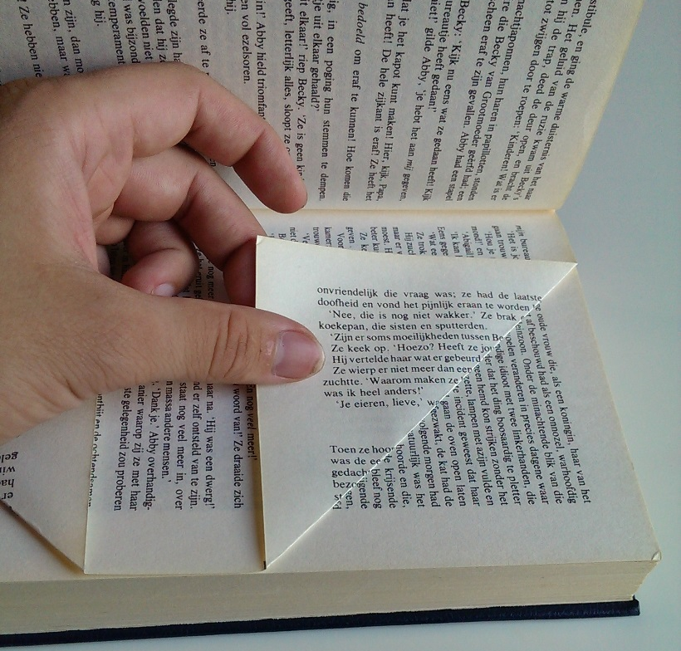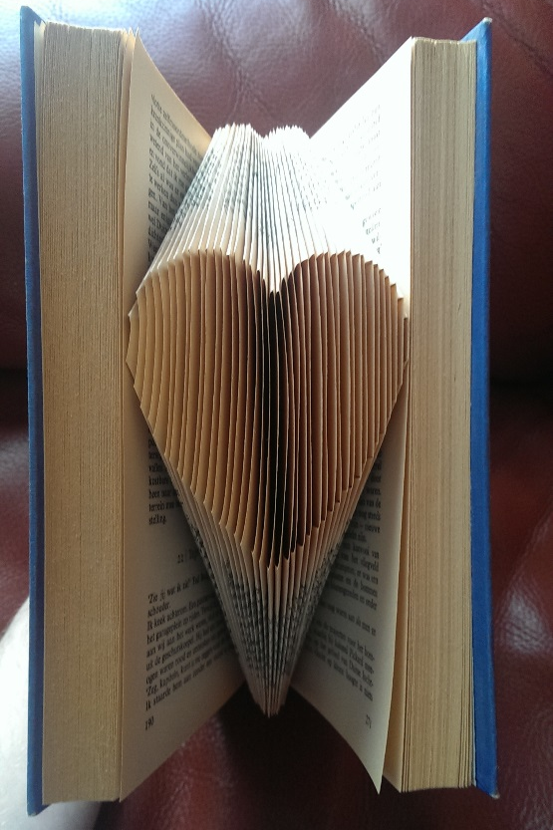
Fold each page twice on the marks you made. Try to keep the folds at 90 degrees or as close to it as possible.
Repeat these steps until you have folded all the marked pages.
Send a photo of your work to rocklibrarystaff@gmail.com to be entered to win a prize!

