Materials:
Flowers, grass, weeds- whatever kinds you like
water color paper
a sheet of regular printer paper
hammer (optional)

Step 1. Gather up and wash some flowers and grasses. (Just to make sure they will work on your nice paper, test them out on some scrap paper first.)
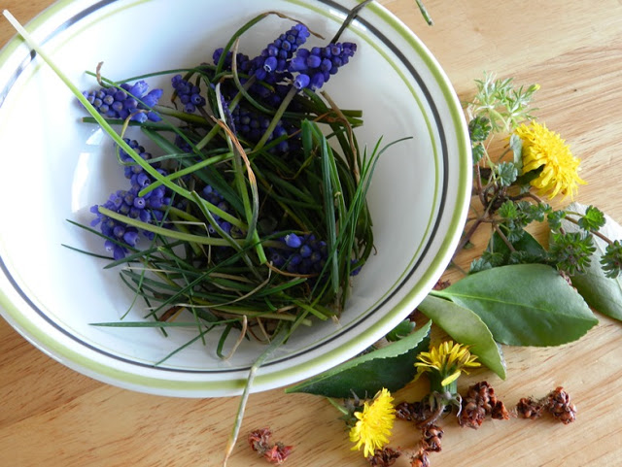
Step 2: Arrange your flowers and grasses on your heavy weight paper.
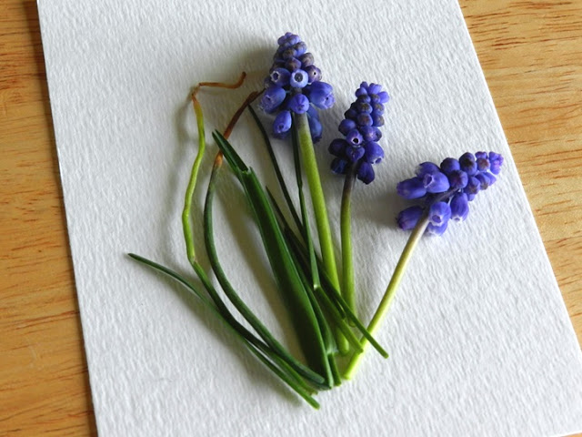

Step 3: Place a regular sheet of printer paper on top of your arrangement- you can fold your printer paper in half if you like.
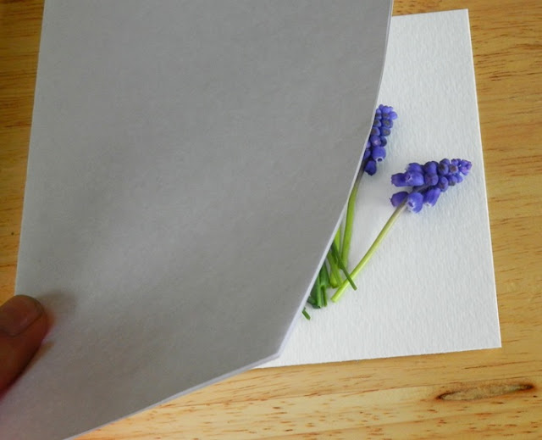

Step 4: Without moving your flower arrangement, press the printer paper on top of it carefully, making sure to squish the juices and natural dyes out of the plants. (This is where you might need a hammer to get the best colors.)
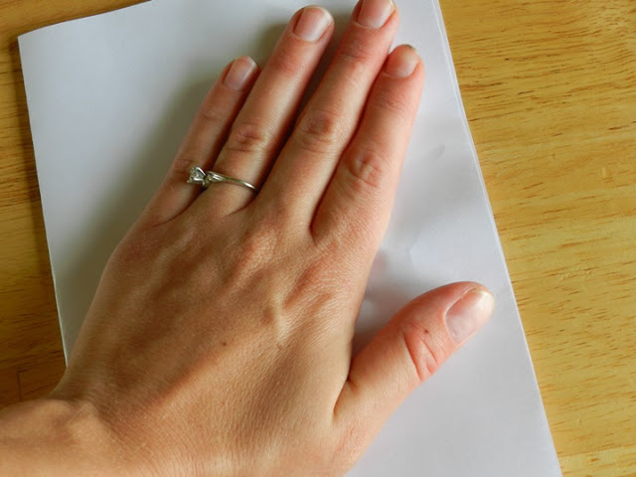
Step 5: Lift the printer paper off and see the prints you made with the dyes of the flowers. Remove the smashed plants and repeat the previous steps to add more to your artwork, if desired.
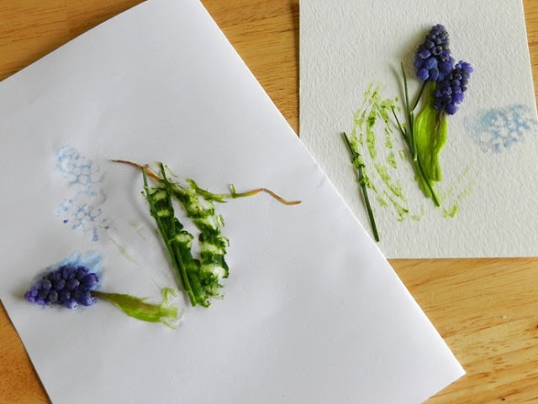

Step 6: Some plant remnants may still stick to your paper, so let it dry and then scrape off the extra stuff.
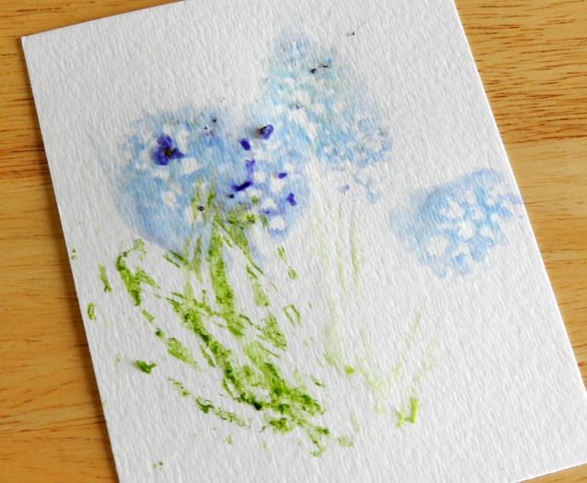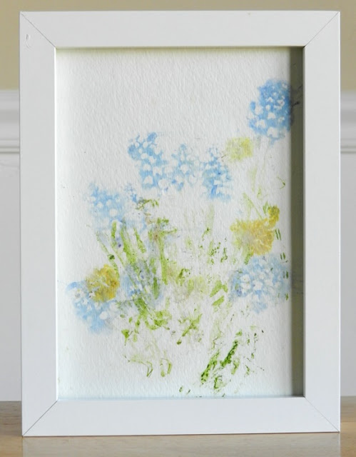

https://www.eliseenghstudios.com

