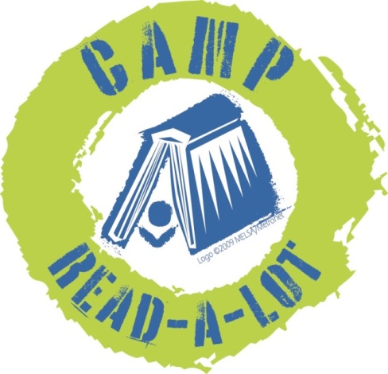
2019
EARLY Childhood LIT
Please read the 30 titles listed plus two “Camper’s Choice”selections prior to Camp. Reports should be submitted no later than August 3, 2018, and should include your personal reaction to the book and how you might use the book in your library or classroom. In order to earn 25 continuing education credits per day, you must read the entire list, report on each book and attend Camp Read-a-Lot on August 7 and 8, 2019.

Note: reports will be made on this sheet: click on the blue text and enter your report (the box will expand as you type) or you can space between titles, print the sheet and write in your reports by hand.

FICTION:

1. The Day You Begin, by Jacqueline Woodson (Kensington Books, 2018)
Click here to provide your personal reaction to this title including how you would use the book in your library or classroom.

2. The Wall in the Middle of the Room, by Jon Agee (Dial Books for Young Readers, 2018)
Click here to provide your personal reaction to this title including how you would use the book in your library or classroom.

3. We Do Not Eat Our Classmates, by Ryan Higgins (Disney-Hyperion, 2018)
Click here to provide your personal reaction to this title including how you would use the book in your library or classroom.

4. Hush, Hush Forest, by Mary Casanova (University of Minnesota Press, 2018)
Click here to provide your personal reaction to this title including how you would use the book in your library or classroom.

5. Small Walt & Mo the Tow, by Elizabeth Verdick (Simon & Schuster Books for Young Readers, 2018)
Click here to provide your personal reaction to this title including how you would use the book in your library or classroom.

6. Hello Lighthouse, by Sophie Blackall (Little, Brown and Company, 2018)
Click here to provide your personal reaction to this title including how you would use the book in your library or classroom.

7. Good Rosie, by Kate DeCamillo (Candlewick, 2018)
Click here to provide your personal reaction to this title including how you would use the book in your library or classroom.

8. I am Enough, by Grace Byers (Balzer + Bray, 2018)
Click here to provide your personal reaction to this title including how you would use the book in your library or classroom.

9. I Walk With Vanessa, by Kerascoet (Schwartz & Wade Books, 2018)
Click here to provide your personal reaction to this title including how you would use the book in your library or classroom.

10. The Rough Patch, by Brian Lies (Greenwillow Books, 2018)
Click here to provide your personal reaction to this title including how you would use the book in your library or classroom.

11. Dreamers, by Yuyi Morales (Neal Porter Books, 2018)
Click here to provide your personal reaction to this title including how you would use the book in your library or classroom.

12. They Say Blue, by Jillian Tamaki (Abrams Books for Young Readers, 2018)
Click here to provide your personal reaction to this title including how you would use the book in your library or classroom.

13. Baby Monkey, Private Eye, by Brian Selznik (Scholastic Press, 2018)
Click here to provide your personal reaction to this title including how you would use the book in your library or classroom.

14. The Donkey Egg, by Jane Stevens (Houghton Mifflin Harcourt, 2019)
Click here to provide your personal reaction to this title including how you would use the book in your library or classroom.

15. Wordy Birdy, by Tammi Sauer (Doubleday Books for Young Readers, 2018)
Click here to provide your personal reaction to this title including how you would use the book in your library or classroom.

16. Sheep Dog, Sheep Sheep, by Eric Barclay (Harper, 2019)
Click here to provide your personal reaction to this title including how you would use the book in your library or classroom.

17. Tiger vs Nightmare, by Emily Tetri (First Second, 2018)
Click here to provide your personal reaction to this title including how you would use the book in your library or classroom.

18. Goodbye Autumn, Hello Winter, by Kennard Pak (Henry Holt and Company, 2017)
Click here to provide your personal reaction to this title including how you would use the book in your library or classroom.

19. Finding Wild, by Megan Wagner Lloyd (Alfred A. Knopf, 2016)
Click here to provide your personal reaction to this title including how you would use the book in your library or classroom.

20. Ocean Meets Sky, by Terry and Eric Fan (Doubleday Books for Young Readers, 2018)
Click here to provide your personal reaction to this title including how you would use the book in your library or classroom.

21. Giraffe Problems, by Jory John (Random House, 2018)
Click here to provide your personal reaction to this title including how you would use the book in your library or classroom.

22. Night Job, by Karen Hesse (Candlewick Press, 2018)
Click here to provide your personal reaction to this title including how you would use the book in your library or classroom.

23. A Parade of Elephants, by Kevin Henkes (Greenwillow Books, 2018)
Click here to provide your personal reaction to this title including how you would use the book in your library or classroom.

24. Strictly No Elephants, by Lisa Mantchev (Simon & Schuster Books for Young Readers, 2015)
Click here to provide your personal reaction to this title including how you would use the book in your library or classroom.

25. Stinkiest, by Steve Jenkins (Houghton Mifflin Harcourt, 2018)
Click here to provide your personal reaction to this title including how you would use the book in your library or classroom.

26. Grow, Raise, Catch, by Shelley Rotner (Holiday House, 2016)
Click here to provide your personal reaction to this title including how you would use the book in your library or classroom.

27. I am Martin Luther King, Jr, by Brad Meltzer (Dial Books for Young Readers, 2016)
Click here to provide your personal reaction to this title including how you would use the book in your library or classroom.

28. A Big Mooncake for Little Star, by Grace Lin (Little, Brown and Company, 2018)
Click here to provide your personal reaction to this title including how you would use the book in your library or classroom.

29. Counting on Katherine, by Helaine Becker (Henry Holt and Company, 2019)
Click here to provide your personal reaction to this title including how you would use the book in your library or classroom.

30. The Crayon Man, by Natascha Biebow (Houghton Mifflin Harcourt, 2019)
Click here to provide your personal reaction to this title including how you would use the book in your library or classroom.

CAMPER’S CHOICE: Select any picture book by David LaRochelle to read and review
Click here to provide your personal reaction to this title including how you would use the book in your library or classroom.
TITLE:
AUTHOR:
CAMPER’S CHOICE: Select a title of your choice (fiction or non-fiction) that meets the following criteria:
- You have not read it before this summer
- Original copyright is no older than 2015
- Ideal for classroom use or free reading
Click here to provide your personal reaction to this title including how you would use the book in your library or classroom.
TITLE:
AUTHOR:

SEND REPORTS TO:
Rebecca Hudson
rhudson@plumcreeklibrary.net
or:
Plum Creek Library System
PO Box 697
Worthington, MN 56187

