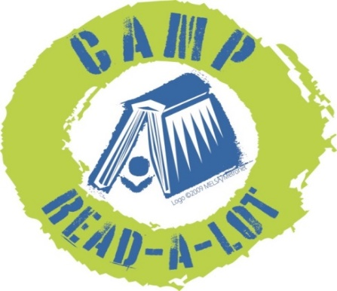
2019
GRADES 9-12
Please read the 11 titles listed plus two “Camper’s Choice”
selections prior to Camp. Reports should be submitted no later than August 3, 2018, and should include your personal reaction to the book and how you might use the book in your library or classroom. In order to earn 25 continuing education credits per day, you must read the entire list, report on each book and attend Camp Read-a-Lot on August 7 and 8, 2019.

Note: reports will be made on this sheet: click on the blue text and enter your report (the box will expand as you type) or you can space between titles, print the sheet and write in your reports by hand.

FICTION:

1. Children of Blood and Bone (Legacy of Orisha), by Tomi Adeyemi (Henry Holt, 2018)
Click here to provide your personal reaction to this title including how you would use the book in your library or classroom.

2. The Prince and the Dressmaker, by Jen Wang (First Second, 2018)
Click here to provide your personal reaction to this title including how you would use the book in your library or classroom.

3. Girl in the Blue Coat, by Monica Hesse (Little Brown, 2017)
Click here to provide your personal reaction to this title including how you would use the book in your library or classroom.

4. The Dark Descent of Elizabeth Frankenstein, by Kiersten White (Delacorte Press, 2018)
Click here to provide your personal reaction to this title including how you would use the book in your library or classroom.

5. Hooper, by Geoff Herbach (Tegan Books, 2018)
Click here to provide your personal reaction to this title including how you would use the book in your library or classroom.

6. Darius the Great is Not Okay, by Adib Khorram (Dial, 2018)
Click here to provide your personal reaction to this title including how you would use the book in your library or classroom.

7. Blood Water Paint, by Joy McCullough (Dutton, 2018)
Click here to provide your personal reaction to this title including how you would use the book in your library or classroom.

NON-FICTION:

8. Don’t Call Me Crazy, by Kelly Jensen (Algonquin, 2018)
Click here to provide your personal reaction to this title including how you would use the book in your library or classroom.

9. The 57 Bus: A True Story of Two Teenagers and the Crime that Changed Their Lives, by Dashka Slater (Farrar, Straus, and Giroux, 2017)
Click here to provide your personal reaction to this title including how you would use the book in your library or classroom.

10. Hey, Kiddo: How I Lost My Mother, Found My Father, and Dealt with Family Addiction, by Jarrett J. Krosoczka (Graphix, 2018)
Click here to provide your personal reaction to this title including how you would use the book in your library or classroom.

11. Just Mercy: A True Story of the Fight for Justice (adapted for young adults), by Bryan Stevenson (Delacorte, 2018)
Click here to provide your personal reaction to this title including how you would use the book in your library or classroom.

CAMPER’S CHOICE: Select any YA title by John Coy to read and review
Click here to provide your personal reaction to this title including how you would use the book in your library or classroom.
TITLE:
AUTHOR:
CAMPER’S CHOICE: Select a title of your choice (fiction or non-fiction) that meets the following criteria:
- You have not read it before this summer
- Original copyright is no older than 2014
- Ideal for classroom use or free reading
Click here to provide your personal reaction to this title including how you would use the book in your library or classroom.
TITLE:
AUTHOR:

SEND REPORTS TO:
Rebecca Hudson
rhudson@plumcreeklibrary.net
or:
Plum Creek Library System
PO Box 697
Worthington, MN 56187

