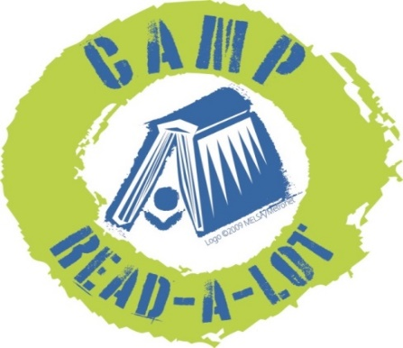
2019
GRADES 5-8
Please read the 13 titles listed plus two “Camper’s Choice”
selections prior to Camp. Reports should be submitted no later than August 3, 2018, and should include your personal reaction to the book and how you might use the book in your library or classroom. In order to earn 25 continuing education credits per day, you must read the entire list, report on each book and attend Camp Read-a-Lot on August 7 and 8, 2019.

Note: reports will be made on this sheet: click on the blue text and enter your report (the box will expand as you type) or you can space between titles, print the sheet and write in your reports by hand.

FICTION:

1. Amal Unbound by Aisha Saeed (Nancy Paulsen Books, 2018)
Click here to provide your personal reaction to this title including how you would use the book in your library or classroom.

2. Front Desk, by Kelly Yang (Arthur A. Levine Books, 2018)
Click here to provide your personal reaction to this title including how you would use the book in your library or classroom.

3. The Parker Inheritance, by Varian Johnson (Arthur A. Levine Books, 2018)
Click here to provide your personal reaction to this title including how you would use the book in your library or classroom.

4. The Truth as Told by Mason Buttle, by Leslie Connor (Tegen Books, 2018)
Click here to provide your personal reaction to this title including how you would use the book in your library or classroom.

5. Ivy Aberdeen’s Letter to the World, by Ashley Herring Blake (Little, Brown Books, 2018)
Click here to provide your personal reaction to this title including how you would use the book in your library or classroom.

6. The Night Diary, by Veera Hiranandani (Kokila, 2018)
Click here to provide your personal reaction to this title including how you would use the book in your library or classroom.

7. Small Spaces, by Katherine Arden (G.P. Putnam’s Sons, 2018)
Click here to provide your personal reaction to this title including how you would use the book in your library or classroom.

8. Dactyl Hill Squad, by Daniel Jose Older (Arthur A. Levine Books, 2018)
Click here to provide your personal reaction to this title including how you would use the book in your library or classroom.

9. Song for a Whale, by Lynne Kelly (Delacorte Books for Young Readers, 2019)
Click here to provide your personal reaction to this title including how you would use the book in your library or classroom.

NON-FICTION:

10. Spooked! How a Radio Broadcast and The War of the Worlds Sparked the 1938 Invasion of America, by Gail Jarrow (Calkins Creek, 2018)
Click here to provide your personal reaction to this title including how you would use the book in your library or classroom.

11. Something Rotten: A Fresh Look at Roadkill, by Heather L. Montgomery (Bloomsbury’s Children’s Books, 2018)
Click here to provide your personal reaction to this title including how you would use the book in your library or classroom.

12. Science Comics: Dogs from Predator to Protector, by Andy Hirsch (First Second, 2017)
Click here to provide your personal reaction to this title including how you would use the book in your library or classroom.

13. Be Prepared, by Vera Brosgol (First Second, 2018)
Click here to provide your personal reaction to this title including how you would use the book in your library or classroom.

CAMPER’S CHOICE: Select any YA title by John Coy to read and review
Click here to provide your personal reaction to this title including how you would use the book in your library or classroom.
TITLE:
AUTHOR:
CAMPER’S CHOICE: Select a title of your choice (fiction or non-fiction) that meets the following criteria:
- You have not read it before this summer
- Original copyright is no older than 2014
- Ideal for classroom use or free reading
Click here to provide your personal reaction to this title including how you would use the book in your library or classroom.
TITLE:
AUTHOR:

SEND REPORTS TO:
Rebecca Hudson
rhudson@plumcreeklibrary.net
or:
Plum Creek Library System
PO Box 697
Worthington, MN 56187

