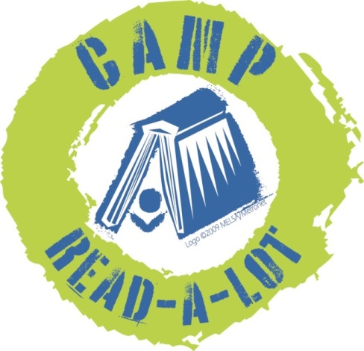
2019
GRADES 2-4
Please read the 18 titles listed plus two “Camper’s Choice”
selections prior to Camp. Reports should be submitted no later than August 3, 2018, and should include your personal reaction to the book and how you might use the book in your library or classroom. In order to earn 25 continuing education credits per day, you must read the entire list, report on each book and attend Camp Read-a-Lot on August 7 and 8, 2019.

Note: reports will be made on this sheet: click on the blue text and enter your report (the box will expand as you type) or you can space between titles, print the sheet and write in your reports by hand.

FICTION:

1. Islandborn, by Junot Diaz (Dial Books for Young Readers, 2018)
Click here to provide your personal reaction to this title including how you would use the book in your library or classroom.

2. Real Friends, by Shannon Hale (First Second, 2018)
Click here to provide your personal reaction to this title including how you would use the book in your library or classroom.

3. Carmela Full of Wishes, by Matt de la Pena (G. P. Putnam's Sons, 2018)
Click here to provide your personal reaction to this title including how you would use the book in your library or classroom.

4. Science Fair Scare (Princess in Black), by Shannon Hale (Candlewick Press, 2019)
Click here to provide your personal reaction to this title including how you would use the book in your library or classroom.

5. Haunted House Next Door, by Andres Miedoso (Little Simon, 2017)
Click here to provide your personal reaction to this title including how you would use the book in your library or classroom.

6. Dragons and Marshmallows, by Asia Citro (Innovation Press, 2017)
Click here to provide your personal reaction to this title including how you would use the book in your library or classroom.

7. Bob, by Wendy Mass & Rebecca Stead (Macmillan Publishing Group2018)
Click here to provide your personal reaction to this title including how you would use the book in your library or classroom.

8. Fish in a Tree, by Lynda Mullaly Hunt (Nancy Paulsen Books, 2015)
Click here to provide your personal reaction to this title including how you would use the book in your library or classroom.

9. Fergus & Zeke, by Kate Messner (Candlewick Press, 2017)
Click here to provide your personal reaction to this title including how you would use the book in your library or classroom.

10. Charlie & Mouse, by Laurel Snyder (Chronicle Books, 2017)
Click here to provide your personal reaction to this title including how you would use the book in your library or classroom.

11. Wedgie & Gizmo, by Suzanne Selfors (Katherine Tegen Books, 2017)
Click here to provide your personal reaction to this title including how you would use the book in your library or classroom.

12. Bad Guys: Do-You-Think-He-Saurus, by Aaron Blabey (Scholastic, 2018)
Click here to provide your personal reaction to this title including how you would use the book in your library or classroom.

13. HILO: Then Everything Went Wrong, by Judd Winick (Random House, 2019)
Click here to provide your personal reaction to this title including how you would use the book in your library or classroom.

NON-FICTION

14. Shark Lady, by Jess Keating (Sourcebooks Jabberwocky, 2017)
Click here to provide your personal reaction to this title including how you would use the book in your library or classroom.

15. The Brilliant Deep, by Kate Messner (Chronicle Books, 2018)
Click here to provide your personal reaction to this title including how you would use the book in your library or classroom.

16. Cute as an Axolotl, by Jess Keating (Alfred A. Knopf, 2018)
Click here to provide your personal reaction to this title including how you would use the book in your library or classroom.

17. Joan Procter, Dragon Doctor, by Patricia Valdez (Alfred A. Knopf, 2018)
Click here to provide your personal reaction to this title including how you would use the book in your library or classroom.

18. Flying Deep, by Michelle Cusolito (Charlesbridge, 2018)
Click here to provide your personal reaction to this title including how you would use the book in your library or classroom.

CAMPER’S CHOICE: Select any chapter book by David LaRochelle to read and review
Click here to provide your personal reaction to this title including how you would use the book in your library or classroom.
TITLE:
AUTHOR:
CAMPER’S CHOICE: Select a title of your choice (fiction or non-fiction) that meets the following criteria:
- You have not read it before this summer
- Original copyright is no older than 2015
- Ideal for classroom use or free reading
Click here to provide your personal reaction to this title including how you would use the book in your library or classroom.
TITLE:
AUTHOR:

SEND REPORTS TO:
Rebecca Hudson
rhudson@plumcreeklibrary.net
or:
Plum Creek Library System
PO Box 697
Worthington, MN 56187

